# 2. Literature study

## Overview

The optimization of a residential electricity system requires knowledge regarding a wide field of disciplines. The literature study presents the research available on the subjects deemed important to successfully implement the optimization system.

First we will establish basic information regarding the current residential electricity model. This will include the setup of the system at a residence - the current pricing structure, as well as expected future developments.

Next we will consider the typical considerations when a house is converted to carry PV renewable systems, as well as extending this setup to include batteries.

Scheduling loads carries hefty weight in itself as a subject of energy systems. We will consider what factors to consider as well as what constraints can be implemented when we go ahead with the optimization. Defining the scheduling setup provides us with information to make a decision regarding optimization techniques.

Optimization is an intriguing field of mathematical study, and requires some discussion in itself once the setup of the scheduling has been decided on.

To design the hardware for the system, we need to specify the requirements to achieve the optimization. We will consider what physical and theoretical constraints we have, as well as how large economic factors play a role in the system.

## The electricity environment in South Africa

The total energy demand for the residential sector makes out 20% of the national demand in South Africa [1. A survey of energy related behavior and perceptions in South Africa]. From [2.Electricity supply statistics 2006, p14] we derive the same statistics, and is additionally provided with the fact that Eskom deliveres in total 193 TWh for the year 2006 – which makes the residential a total of 38.6 TWh.

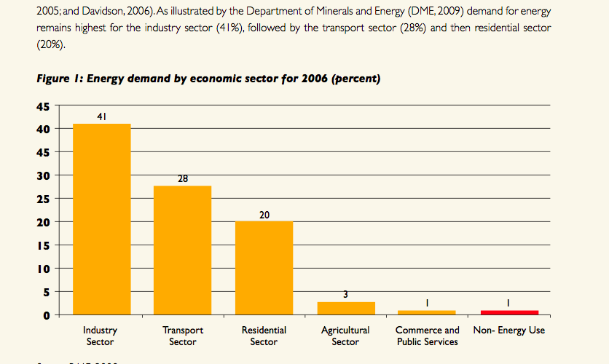

Eskoms averaged demand profile [2. Electricity supply statistics 2006, p16] is shown in figure 5.

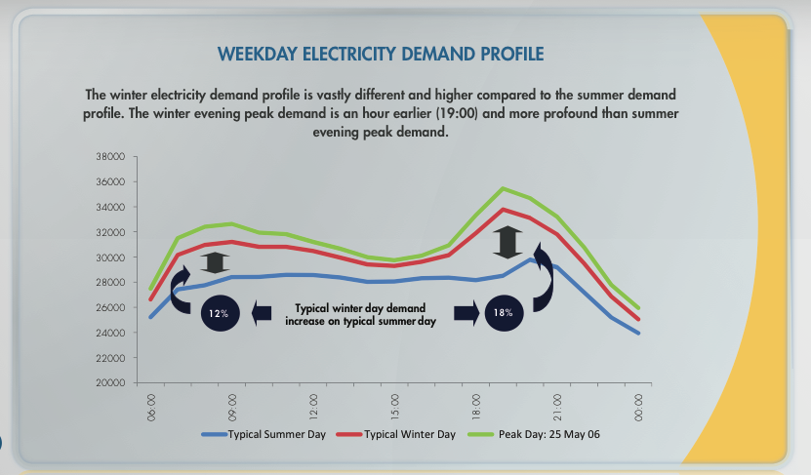

A clear peak in demand can be seen in the morning hours from 7AM to 9AM, as well as again in the afternoon from 5PM to 9PM.

Eskom has made a clear statement to residential users [4. Eskomidm.co.za/residential] to decrease consumption by turning off their electric geysers and swimming pool pumps during the afternoon peak, for a potential load decrease of *onderskeidelik* 2940 MW and 60 MW.

### DSM

To meet increased demand for electricity, electric utilities simply increased demand. For various reasons as stated in [3. The concept of demand side management for electric utilities] utilities had to look for other methods to meet demand. By implementation of a variety of strategies, utilities could influence the demand of the client and could thereby increase system efficiency and decrease the load on the system. This strategy was dubbed Demand side management (DSM).

To achieve demand side management, Eskom started Integrated Demand Management. This section of Eskom deploy the DSM strategies through, amongst others, promotion and installation of solar geysers.

## Residential energy systems

### Introduction

To identify where optimization can be applied in the residential electrical system, we familiarize ourselves with the setup that we can expect to practically be working with. We will consider the typical system into which this project can be integrated and how the system will look if renewable energies are implemented.

### Defining the residential setup

We establish a set of assumptions about the residential system that will be used to optimize schedules on.

As can be deducted from the objective of the thesis, the residential system should carry PV panels for renewable energy in-feed. We should provide for the possibility of energy storage (batteries is implied, but energy storage can also refer to storing of energy in hot water).

The optimization is to be done on appliances such as the swimming pool pump and the geyser.

Therefore, we establish the following baseline of the residential system: A system that contains uncontrollable and uncontrollable loads, with a renewable energy in-feed used in conjunction with battery storage. The system will be grid connected to allow for feeding surplus energy from the renewable source into the grid.

### Renewable household setup

Residential electrical systems with renewable in energy in-feed and optimization exist and have successfully been implented. Figure x shows such a system from SMA [3. SMART_HOME_FromSMA].

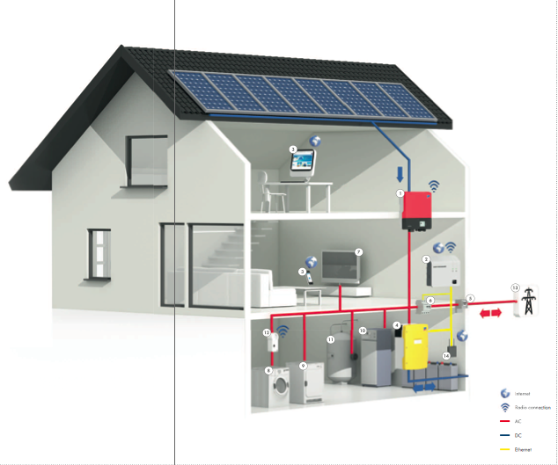

From this we can identify several important components from the system:

PV panels are connected to the load through an inverter, which converts the DC input into standard AC.

A battery charge controller is connected between the AC system and the batteries.

To log energy usage, the system controller can make use of wireless energy meters.

### Generating household profile data

As will be seen from the discussion on scheduling, optimization requires that we provide energy profiles for a collection of appliances.

To explore the study of load profile generation for residences, we first refer to [4. Generating energy load profile]. This paper presents a bottom-up method where a profile for each load, according to a set of parameters defined in the paper. The profiles are then added to create a representative profile.

Each profile is constructed by use of the following equation:



where the factors are

Pstart = , Pseason= , Phour=, Pstep=, Psocial =

With the parameters

A=, W=, deltcomp=, sigflat=, h, d.

The author presents results that can be considered to deliver accurate results:

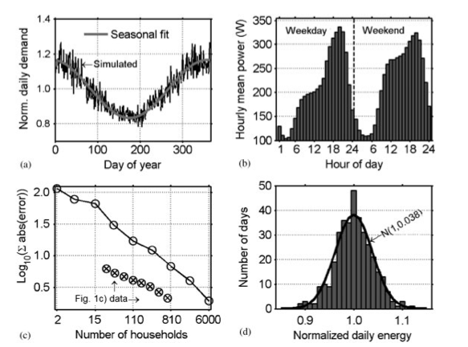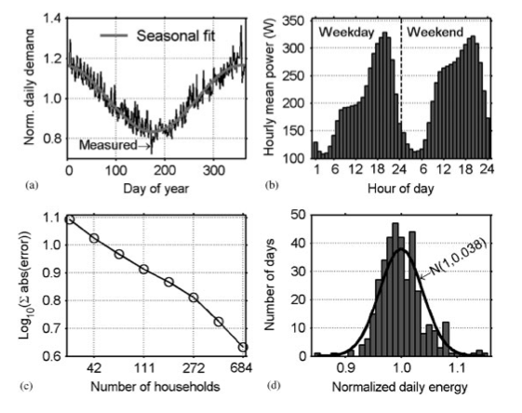

Figure: Real data vs simulated data

It should be noted that determining the factors in the equations require specific and elaborate research into various sources, as mentioned in [4].

<Boek 1 geel flag>

although in itself, generating household profile data is an entire study, for our purposes of determining how effective optimization is is not too reliant on the profile. We construct a simple profile that is based on a suggested small household with rated appliances with predictable usage.

As the topic of research is optimization of loads, the most common loads that we can expect to optimize are the swimming pool pump and the geyser. Other loads that can be controlled is ____

Amount of energy usage per appliance and how large a part the geyser and the swimming pool takes of the total.

Renewable house setup – The SMA setup

The energy flow diagram showing how energy is distributed within the system

The TOU, and the setup whereby we assume that no money is received for delivering to the grid but money is paid to withdraw from the grid. HomeFlex system.

## Solar design and aspects

### Introduction

For the purpose of optimization, we require a model to predict a half-hour-averaged profile for the amount of energy we can expect from the PV panel.

Designing a solar system for a residential customer is a challenge on it’s own and the myriad of considerations is beyond the scope of this document. We do however discuss the typical process and highlight important considerations that are relevant to the optimization within this document.

### PV panel sizing

PV panels aim to lessen the dependancy on grid-provided energy. During the da

### Battery sizing

Batteries can serve two main purposes in a renewable system:

1. Batteries provide backup power in case the grid cannot provide electricity
2. Batteries can improve the efficiency of the renewable system by storing surplus energy that would normally be fed back into the grid. It can also supply energy for small durations of cloud cover and recharge immediately as soon as the clouds pass. (VOORBEELD VANAF SMA dokumente)

The economics regarding the battery were not considered in the design of this thesis, but from research it is clear that battery cost is too high to be justified by the efficiency increase that it brings to the system. The main reason that batteries are introduced to the system is for the ability to provide backup power in case of power outages.

Battery sizing is determined by the amount of load it has to be able to carry for a specified amount of time. A simple design example would look like the following: [SIT VOORBEELD VAN N DESIGN HIER IN]

## Scheduling as system optimization

### Introduction

Scheduling can be subjected to a vast amount of constraints and conditions. These constraints and conditions can often be identified from a written description of the system.

This topic considers methods of optimizations that has been previously used and what scheduling factors were considered in the analysis.

After other research has been studies, an appropriate model will be chosen for our optimization, as well as the constraints that we will apply to the scheduling setup.

### Problem definition

Prentjie:

As discussed in [DIE HOOFSTUK WAT LASTE BESPREEK] we will consider our schedulable loads as the swimming pool pump and the geyser.

Knowledge of the basic operation of these appliances allows us to define what measures we would like to implement.

We will run optimizations for different sets of measures that will allow us to study the effect of the measures we implement on the efffectivity of the optimization.

### Optimization from previous

### Optimization method and cost function

### Static versus dynamic optimization

The aim of the thesis is “optimal scheduling of load and storage operations” [AANHALING UIT OPDRAG].

Optimization would typically require the following aspects:

Definition of the system as per the parameters that needs to be optimized

The boundaries and constraints that the parameters are subjected to

The value of the parameters initially, before optimization is applied

The object function or cost function, which defines what we are trying to minimize.

These specifications can be stated in informal terms, describing the system. However, to apply this to optimization, these need to be converted to mathematical entities that we can apply to a suitable mathematical optimization algorithm.

It is important to note that the thesis does not specify to what purpose the optimization needs to be done. Optimization for one purpose would almost certainly not give the same parameters as for another optimization e.g. optimization to minimize cost to the owner and optimization to minimize peak loads for the utility would deliver different results.

We will need to determine how the problems need to be set up for different optimizations

Furthermore, we will assume the aim of the optimization is minimizations of cost to the owner.

## Scheduling hardware design

Hardware

To perform optimizations

To hold schedule

To switch loads on and off

The hardware needed to switch loads on and off

What wireless systems exsist